Starck 2

One-piece toilet

Bottom supply
#0163010001
Article code | Description | Supplier | IC Price | Price $
0074110600 | Fill valve | Fluid Master
0074122000 | Refill hose | Fluidmaster
0074122100 | Fixation Kit for installation | Fluidmaster
0074132700 | Flush valve | Coast Foundry
9990405 | Flapper | Coast Foundry
0163990000 | Tank Lid | Duravit
0074001000 | Handle lever,  complete –chrome | Coast foundry
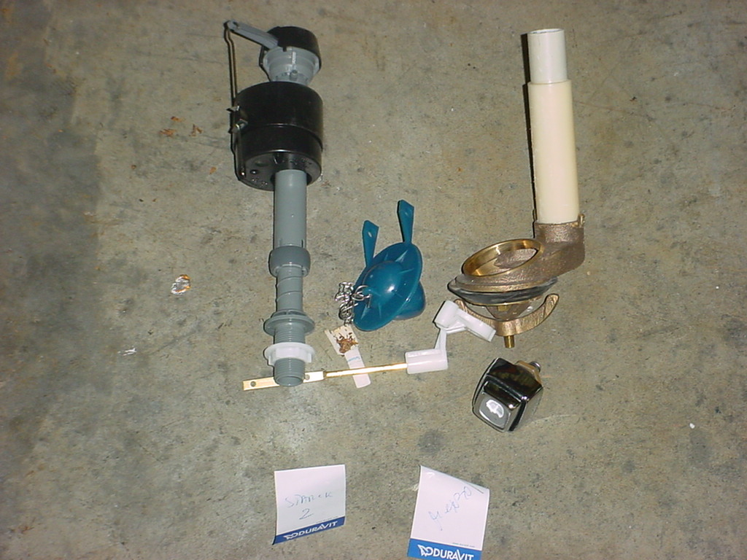
Handle Lever
Fill Valve
Flush Valve
Flapper
Seat:
Article code | Description | Supplier | Price $
0063051000 | Hinges | Duravit | 35
1001460000 | Seat Buffers | Duravit | 5
0050501000 | Seat Inserts | Duravit | 5

